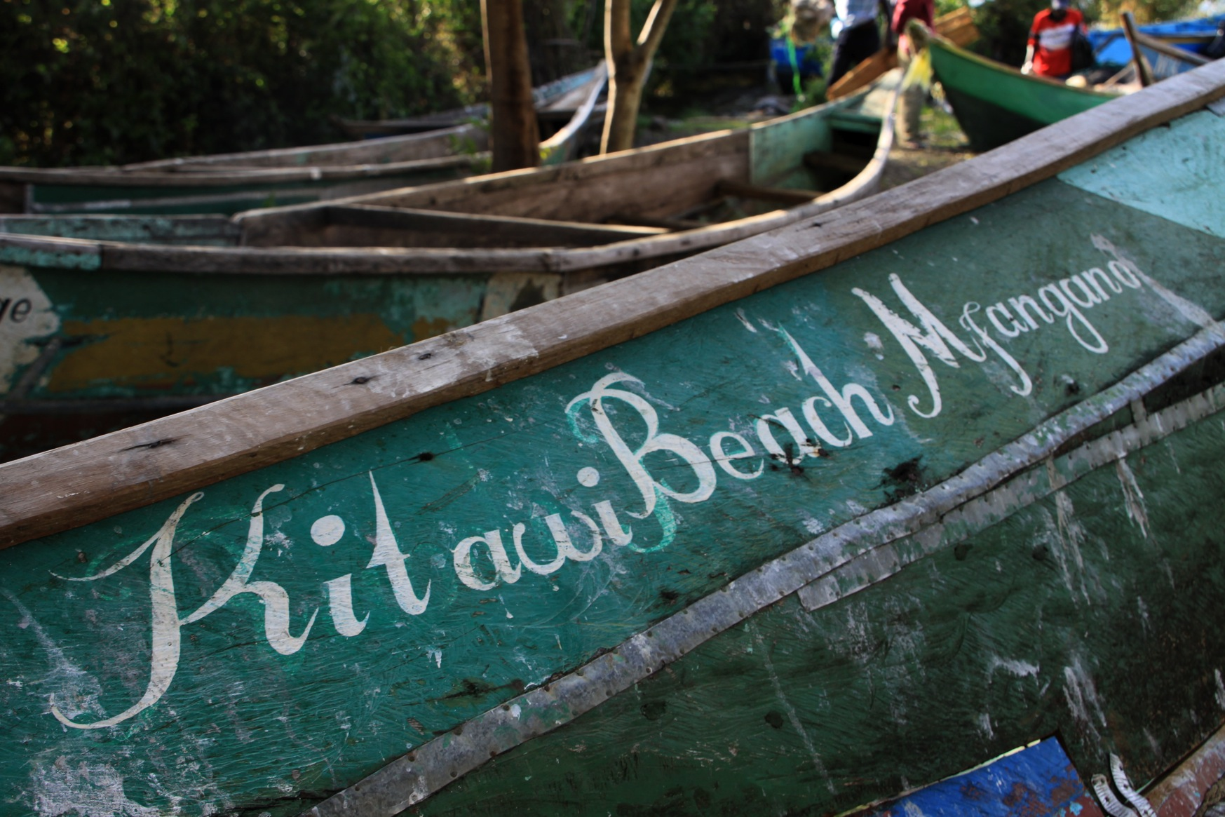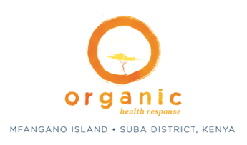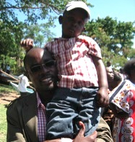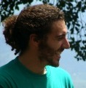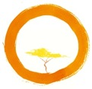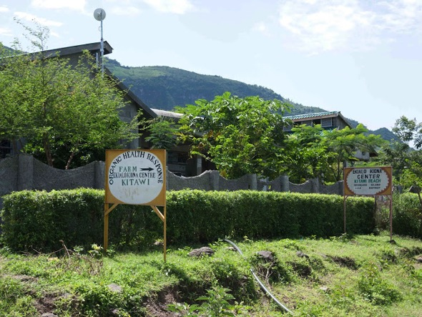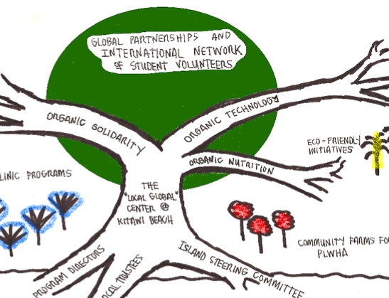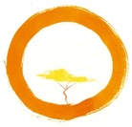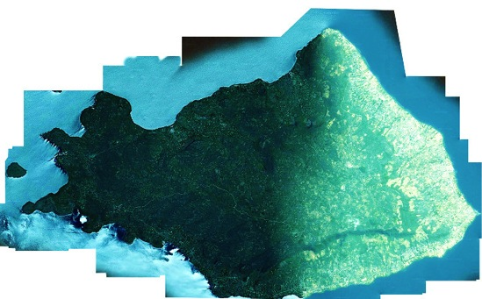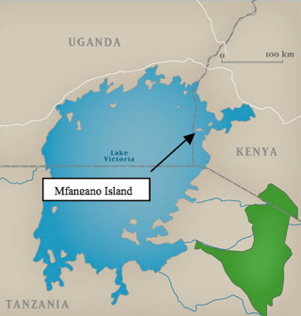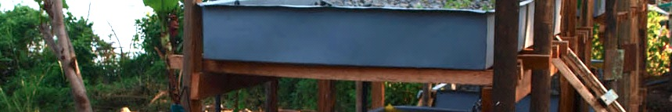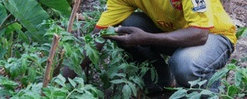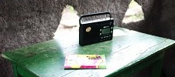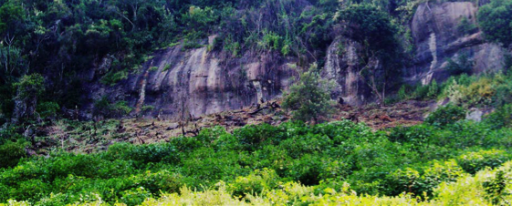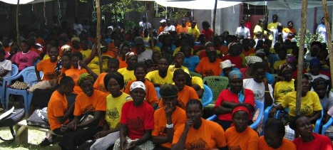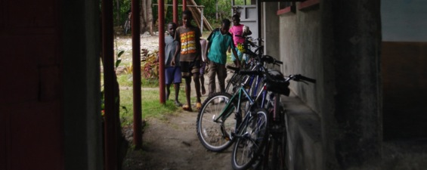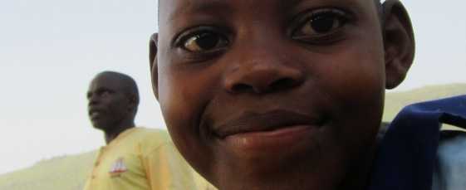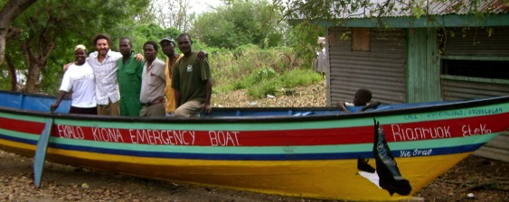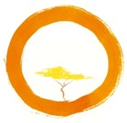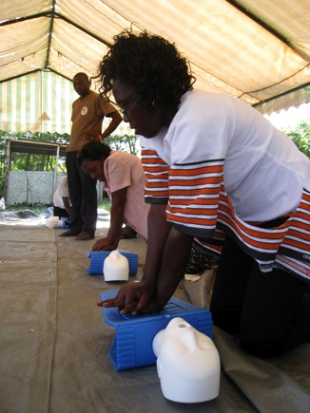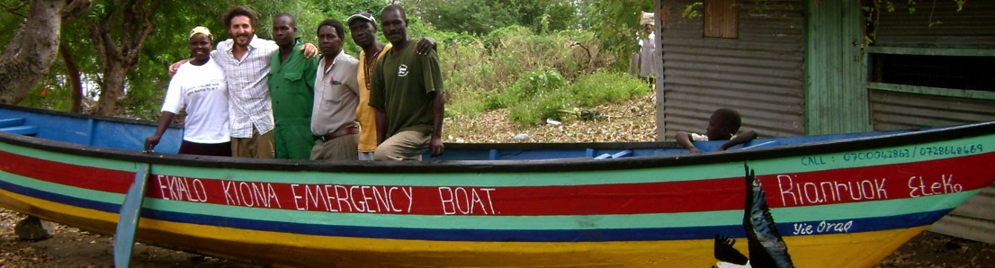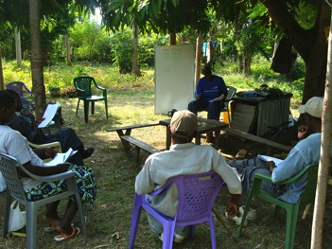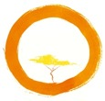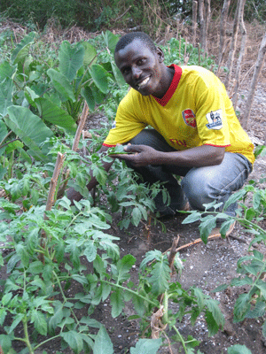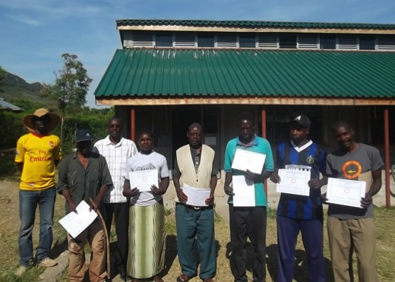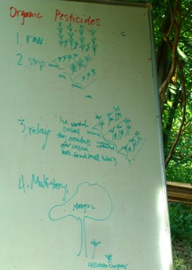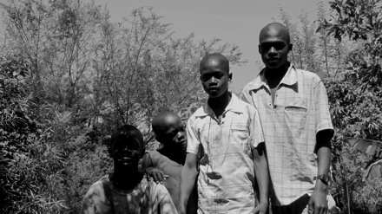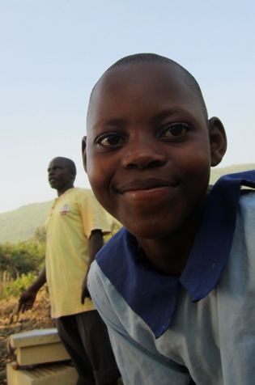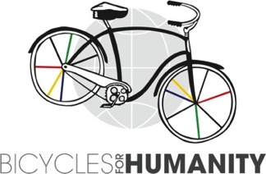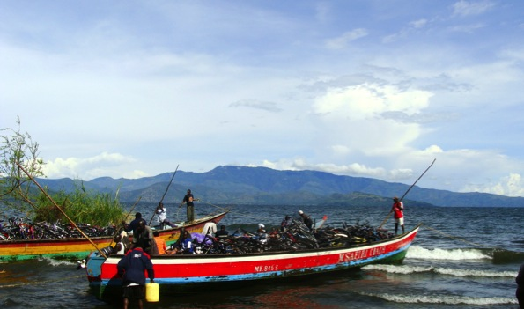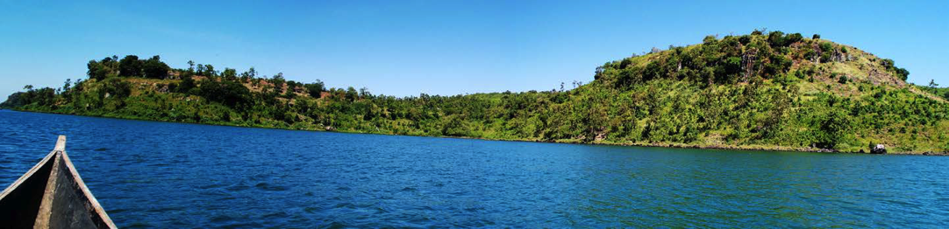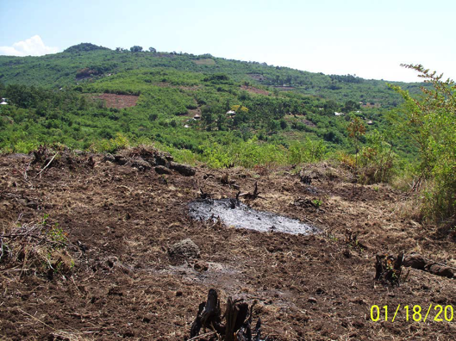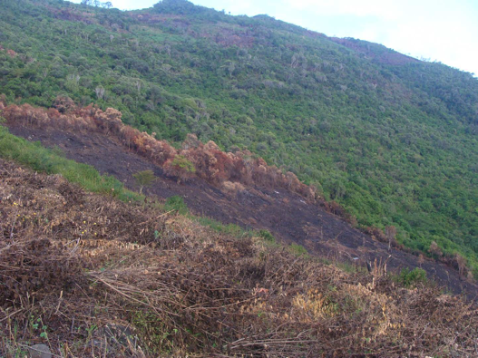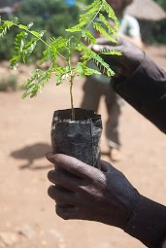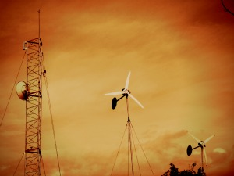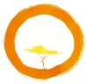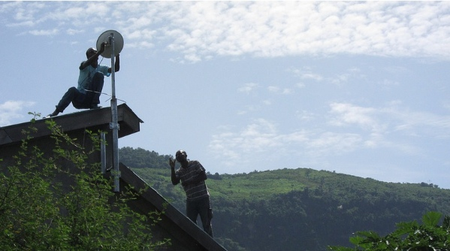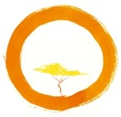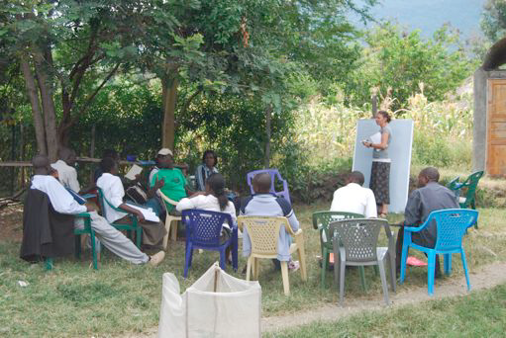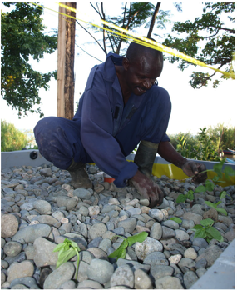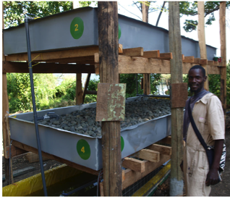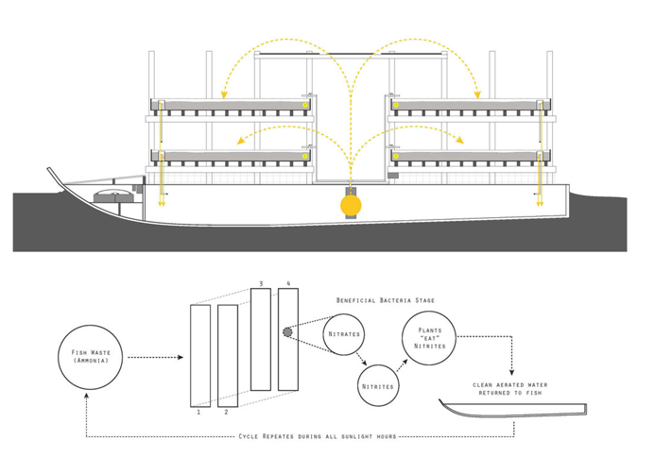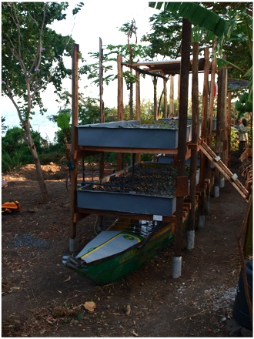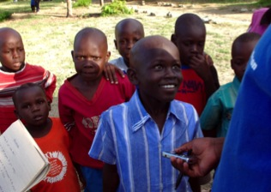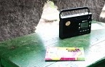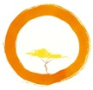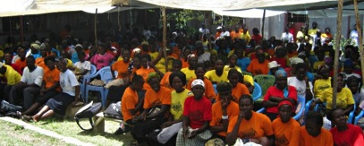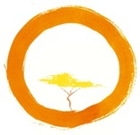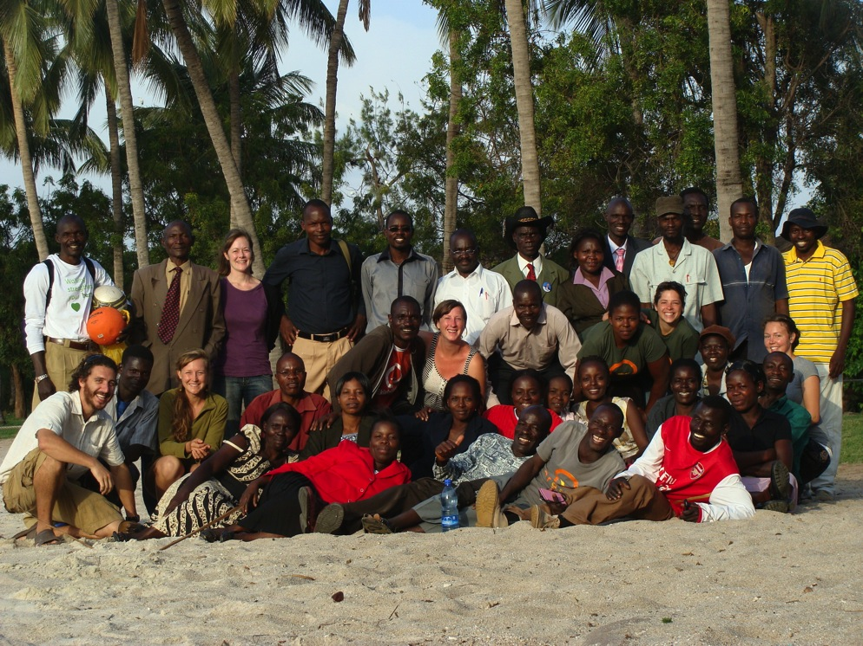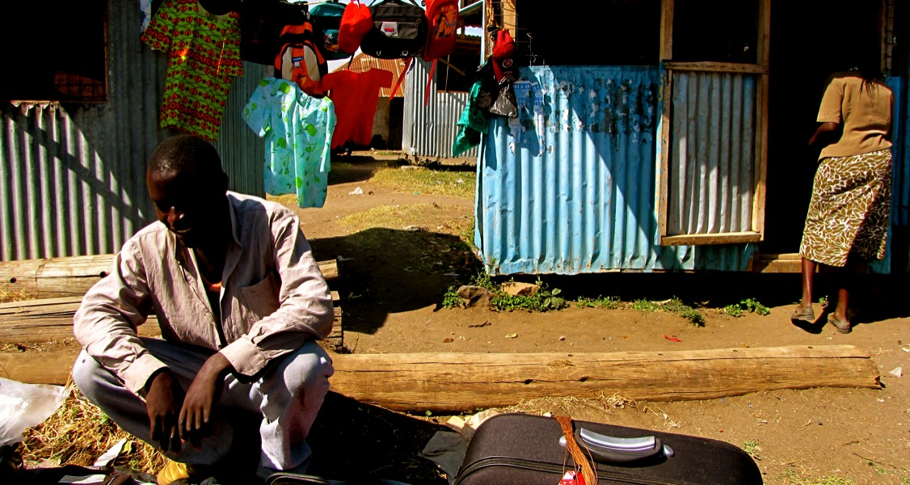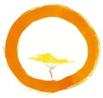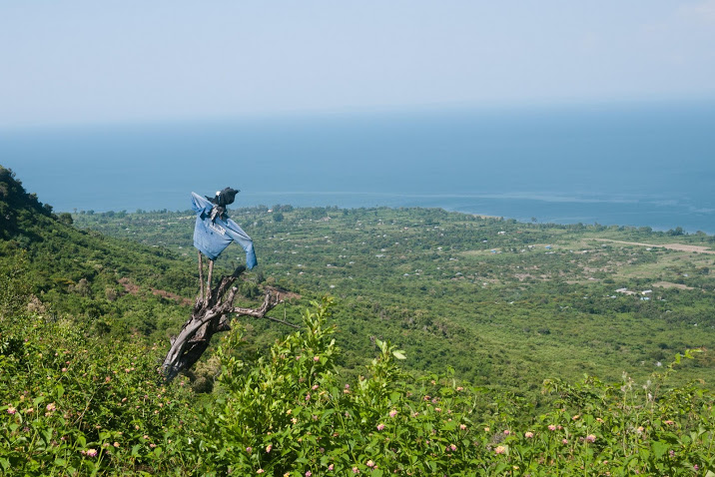

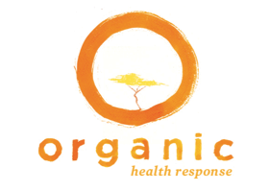

2012 ANNUAL REPORT

WWW.ORGANICHEALTHRESPONSE.ORG

WWW.ORGANICHEALTHRESPONSE.ORG

Letter from the Directors …………………

Mfangano Island …………………………………..

Mission, Story & Model ……………………

2012 Accomplishments ……………………………

Staff and Volunteers ……………………………

Many Thanks …………………………………………

Financials ………………………………………

What’s Next: 2013 and Beyond …………………

O RGANIC HEALTH RESPONSE - 2012 ANNUAL REPORT

TABLE OF CONTENTS

WITH PEACE,

Chas Salmen and Richard Magerenge

LETTER FROM THE DIRECTORS

We learned a few things actually. We taught ourselves how to build communication towers, wind-turbines, and radio stations on remote mountainsides. We learned how to organize coalitions of Elders, students, and farmers to protect our shrinking forests. As fish continue to disappear in the lake, we learned how to grow them inside our old boats in solar-powered aquaponic systems. We learned to trust each other, helping hundreds of people living with HIV disclose their HIV status for the first time. We learned how to ride bikes, transport pregnant mothers by boat, and conduct focus group discussions. We learned that as a community we have the ability to transform Mfangano’s deep challenges into creative solutions that will last for decades and inspire people around the planet.

OHR is an idea that is now alive, a partnership that has grown into a network. An organization that is able to truly respond to the evolving needs of the rural communities of Lake Victoria. The Ekialo Kiona Center is our HQ on Mfangano Island, our administrative umbrella, solar-powered field station, training center, bike shop, and favorite lunch spot. Over 2000 members have joined the EK Club, and new members learn their HIV status everyday.

As Directors, we learned this year that we are part of an incredible team. This young organization is blessed with remarkable, talented, flexible, and very hard-working people. Our co-directors and managers in US and Kenya are forward thinking, organized, and considerate. Our Ekialo Kiona staff is proactive, sensitive, and courageous. Our community researchers are competent and insightful. Our volunteers are generous with their time and enthusiasm. In Kenya, in Minnesota, Wisconsin, Colorado, in San Francisco, in DC, “Responders” are using their diverse skills to contribute in meaningful ways.

We also learned this year that diversity is our deepest strength. OHR is actively cultivating a broad network of community programs. We’re tackling diseases, famine, deforestation, and unemployment. We’re building communication systems, small businesses, planting tree nurseries and growing fish farms. By sharing resources, training local staff, and attracting different types of partners, we’ve become increasingly sustainable and adaptive. Our mission is our local home: the island of Mfangano. And now more than ever, we realize we are not alone out in the boundary waters of Africa’s largest freshwater lake. We’re learning that we have friends and supporters around the world who are now learning about us for the first time. We’re learning that the impact of all these creative, local programs may extend beyond far our remote shores.

Thank you for being a part of our team. Richard and I are incredibly grateful for your support and trust. It remains our great joy everyday and our deep honor to lead this organization with you.

WE LEARNED SOMETHING IN 2012…

In 2010 we opened doors to the **Ekialo Kiona Center (EK),** a solar-powered IT and resource facility at Kitawi Beach on Mfangano Island. EK provides free and unlimited access to computers and the region’s first broadband Internet to any resident who agrees to a confidential HIV test with a professional counselor. This center is an invaluable educational workshop facility to empower the endangered Suba people with technology to reshape and strengthen the landscape of HIV care and prevention in the community.

OHR is rounded in the recognition that the health of human beings is fundamentally connected to the strength of their communities and the sustainability of their environments. We seek to augment health services by taking into consideration local understandings of disease, and integrating the power of biomedical science with the insight of indigenous knowledge.

OUR MODEL

WWW.ORGANICHEALTHRESPONSE.ORG

The **Organic Health Response (OHR)** was founded in 2008 by a group of Kenyan farmers, health workers, teachers, and youth, along with a team of international students, designers, and activists. Through local and global partnerships, we equip our rural villages with resources and training to respond as unified communities to the devastating impact of HIV/AIDS across Lake Victoria, and the overwhelming socio-economic, epidemiological, and ecological challenges we face.

OUR STORY

We seed community health on Mfangano Island, Lake Victoria, Kenya. Our focus is on social solidarity, technology, and environment.

MISSION, STORY & MODEL

OUR MISSION

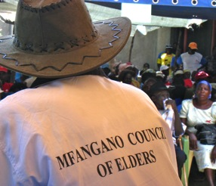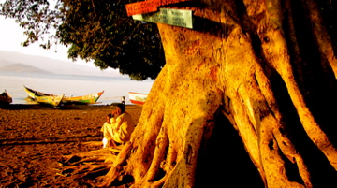

The remote communities of Mfangano face many serious and immediate health challenges. Poverty and disease has forced these vulnerable communities to make dangerous changes to their local environment in order squeeze out enough to survive.

**With over 30% of the population infected with HIV, Mfangano and the surrounding islands represent one of the most HIV prevalent populations on this planet.**

The sources of HIV-risk in this population are numerous and broad;

* An exploitive global Nile perch fishing industry
* The convergence of thousands of migrant fishermen from

across East Africa

* The subsequent cash explosion within impoverished communities
* Intense gender inequities
* Customary trade practices such as *jaboya* (aka “fish-for-sex”)
* Widespread food insecurity
* Natural resource degradation

The numerous sources have culminated in a perfect storm of HIV/AIDS related risk and ill-health. Deforestation on the mountain and over-fishing in the lake has taken a huge toll, threatening annual rainfall and draining the local economy. This is a decisive time to address the serious environmental and health threats facing indigenous people living along the shores of Lake Victoria.

**Without immediate and effective action, the indigenous Suba language and way of life may disappear within a single generation.**

Mfangano Island, in the heart of Lake Victoria, is home to approximately 26,000 people of Suba and Luo descent. The small beach villages that line the shores of these islands are accessible from the mainland only by a 2-hour ride on wooden outboard canoes. Fishing and subsistence farming are primary occupations for the majority of residents. People here speak English, Swahili, Luo, and Suba—a language spoken nowhere in the world other than the shores of Lake Victoria.

MFANGANO ISLAND, LAKE VICTORIA, KENYA

BROADBAND INTERNET

AQUAPONICS

AGRICULTURE

EMERGENCY BOAT

2012 ACCOMPLISHMENTS

RADIO

MICROCLINICS

REFORESTATION

BIKES

SCHOLARSHIPS

RESEARCH

REFORESTATION

EKIALO KIONA EMERGENCY BOAT

**EK Launches Region’s First Ambulance Boat**

In the rain or in drought, for families in poverty or plenty, the EK Ambulance Boat will continue to be an essential service to the Mfangano Island community and will strive to be a model for emergency services around Lake Victoria.

* Secured the donation from a local boat-owner of a 35ft wooden skiff and 40hp outboard motor
* Refurbished the boat with a fresh coat of paint, sealed leaks, and outfitted it with seating and a canopy for emergency medical transport
* Recruited and trained a local, on-call ambulance crew, consisting of local boat drivers, motorcycle drivers, and health providers
* Completed a regional resource assessment of surrounding hospitals and clinics in order to establish an appropriate emergency triage protocol
* Trained 10+ locals in First-Aid and Wilderness EMS, and activated them to be the first of many community “Emergency Responders”
* Safely and successfully transported over 10 individuals to appropriate medical services on the mainland.

Home to deadly snakes and frequent trauma, emergency health services are virtually non-existent on Mfangano Island. When someone becomes seriously ill, he or she frequently encounters dangerous delays in treatment as families struggle to find urgent transport and the finances to pay for it.

Through the generous donations of Kenyan and American “responders,” the Ekialo Kiona Center has established the ***region’s first Ambulance Boat*** and has begun coordinating emergency care for our remote island communities. With 24-hour nurse triage, an on-call boat crew, and a fuel reimbursement policy, the EK Ambulance Boat allows Kenyans to get the care they need, when they need it most.

Our EK Emergency Team, headed by Kitawi resident Walter Opiyo in coordination with local & international medical providers, is very proud of the strides we’ve made in 2012:

With its roots as a WWOOF farm, The EK Demonstration Farm has always been a place for informal learning.  You can stop in any time you happen to be free, eat fruits as you wander under the lush banana, papaya, mango and citrus trees while you ask about our newly installed drip irrigation system, or find yourself learning about soil health if you offer to lend a hand at digging.

This year, our greatest accomplishment has been organizing more formal agricultural workshops, seminars, and trainings to support our already established informal educational services.  Twice a week for 3 months we offered drop-in classes for those that wanted to learn the basics of sustainable agriculture.  We organized seminars discussing genetically modified organisms, nutrition, and how deforestation has affected agriculture and how agriculture is affecting deforestation.  We've certified six local farmers in Level 1 of our sustainable agriculture curricula.  This all could not have been done without the hard work of our EK Demo Farm owner and assistant manager who at the same time gave formal instructing a first-time try.   We estimate nearly 500 community members attended and participated in our teachings!

AGRICULTURE

**EK Agriculture Department Focuses on Education in 2012** With it's roots as a WWOOF farm, The EK Demonstration Farm has always been a place for informal learning.  You can stop in any time you happen to be free, eat fruits as you wander under the lush banana, papaya, mango and citrus trees while you ask about our newly installed drip irrigation system, or find yourself learning about soil health if you offer to lend a hand at digging.  This year, our greatest accomplishment has been organizing more formal agricultural workshops, seminars, and trainings to support our already established informal educational services.  Twice a week for 3 months we offered drop-in classes for those that wanted to learn the basics of sustainable agriculture.  We organized seminars discussing genetically modified organisms, nutrition, and how deforestation has affected agriculture and how agriculture is affecting deforestation.  We've certified six local farmers in Level 1 of our sustainable agriculture curricula.  This all could not have been done without the hard work of our EK Demo Farm owner and assistant manager who at the same time gave formal instructing a first-time try.   We estimate nearly 500 community members attended and participated in our teachings!

We are in one of the most challenging economic eras Mfangano has ever known. A convergence of factors has made it nearly impossible for too many families to come up with the money needed for their children’s High School education.

* 1 of 3 households have taken in an orphan due to HIV
* 8 of 10 households are unable to pay for a member’s tuition
* Over 65% of households have little or no support with school fees

from outside sources

Since the birth of OHR, the community has expressed desperation about how unreachable education is. In 2012, it is with great pride that OHR announces the birth of the EK Scholarship Program.

This community-driven scholarship has begun to inspire students across the island with the opportunity of education. Through a precise and deliberate effort, our scholarship committee has created an application process, conducted outreach, and fundraised across the globe. Community excitement is evident in that only two weeks after the application period opened we have received over 75 completed applications. Mfangano has good schools, caring teachers, and bright students; we are proud to report that very soon we will have our first set of empowered EK Scholars to carry OHR’s mission into future generations.

2012 Accomplishments:

* Formed a scholarship committee and hired a scholarship coordinator
* Developed a multi-paged application that solicits teacher and community recommendations and multiple essay questions in addition to grades. We want our scholars to not only excel academically, but also to demonstrate commitment to their community, so that they may use what tools they learn in school to better Mfangano
* Created a precise evaluation process so that the community will trust our process and not fear corruption
* Coordinated with schools, churches, and local government to ensure community support
* Raised over $4000 through volunteer outreach and community fundraisers in both Kenya & the US
* Held instructional application workshops at local schools
* Inspired students across Mfangano Island with the opportunity of education!

It is with great anticipation that we process the applications. We will announce our 2012 EK Scholars this winter. Check back at our website soon to learn about this powerful group of students!

Community-Matched Student Scholarships

EK SCHOLARSHIP PROGRAM

**Inspiring Mfangano with High School Scholarships**

* Successfully coordinated the transport of over 1 ton of bikes across sea, land & lake to reach Mfangano
* Hired EK Bicycle Shop staff, including bike manager Tielen Masanga
* Held a 3-day bike maintenance workshop at the EK Center
* Repaired and successfully distributed over 200 bikes to EK Members and local Community Health Workers!

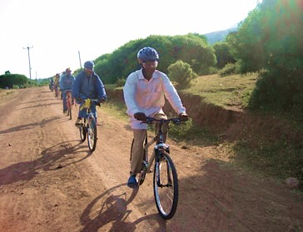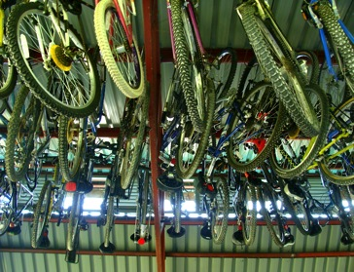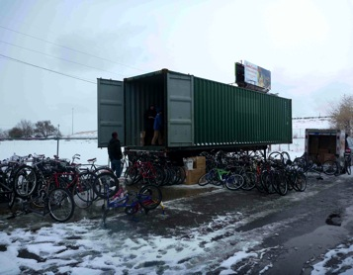

* Secured the donation of 300+ bikes from Bicycles for Humanity – Colorado
* Received a generous donation of 350 brand new helmets courtesy of Greg Lynch of Minnesota!

2012 was a year of fast and furious progress

for the Ekialo Kiona Bicycle Shop!

By offering discounted bikes to EK members, the Bike Shop encourages local residents to learn their HIV status, and has brought in an estimated 300 new members!

In partnership with Colorado-based Bicycles for Humanity, the Ekialo Kiona Bicycle Shop brings safe and affordable transportation to Mfangano Island! The project has transported, repaired, and distributed over 200 used mountain bikes to Ekialo Kiona Center members. Doing so has allowed EK members better access to healthcare facilities, and has promoted job creation & sustainable technology innovation.

EKIALO KIONA BICYCLE SHOP

**EK Bike Shop Transforms Transportation on Mfangano**

In 2012, OHR established a reforestation committee to address this quickly progressing environmental and cultural disaster.  The committee has successfully submitted a request for Gazettement from the Kenyan government after many months of community meetings, educational seminars, petitions, and collaboration.  **This legal conservation document will win us government support and legitimacy to effectively regulate cutting and burning of slopes of 50% and greater, waterways, and sacred areas.**

As support, the EK Demonstration Farm has established a tree nursery where it has freely donated nearly 2000 tree seedlings to households, churches, and schools on Mfangano.  With the help of a rotary grant from Fort Collins, CO, we are looking forward to expanding our youth education services with an integrated agriculture and forestry curriculum for high school students.  Our future lies in their hands!

Together, Mfangano Chiefs, elders, community members, Ekialo Kiona, and U.S. graduate students are addressing the estimated 30% loss of local forests in the last 5 years.  The many forces of climate change, over-fishing, aggressive agricultural practices, have sent the Suba people fleeing to the medicinal and sacred hillsides for easily accessible (traditionally communally owned) fertile forest soil.

REFORESTATION

**Reforestation Program Sprouted & Growing Branches!**

Already the Internet has opened up new doors for health, agriculture, and education on Mfangano. Stay tuned for updates from this small island in Africa that has some exciting ideas to share with the whole world!

Landmark steps by OHR and their broadband partners at *Inveneo* and *Access Energy* in 2012:

* Local builders and welders from Mfangano designed and constructed their own 56-ft hybrid wind/solar communications tower on top of Mfangano mountain. This tower was carried piece by piece up the mountain and assembled on a piece of land donated by a local family who wanted “free Internet” to be their legacy to the island.
* Power for the whole set-up comes from a hybrid wind/solar energy harvesting system designed, built locally and installed by the Kenyan outfit [***Access:Energy***](http://accessenergy.org).
* OHR worked with [***Inveneo***](http://www.inveneo.org) to establish a 90-km Wifi Link connecting Mfangano Island to a *Ubiquiti Rocket* dish on an 18-story building in the nearest city of Kisumu. With a Fiberoptic backbone in Kisumu, this link opens up a large broadband pipe with 20Mbps+ capacity!
* Designed and installed by a Nepalese radio engineer they met over the Internet (a south-south collaboration), OHR added a wind-powered radio transmitter to their tower to launch the world’s first Suba language community radio station!

BROADBAND INTERNET

**Free WiFi in the Heart of Lake Victoria**

For 26,000 Kenyan people living in the heart of Lake Victoria on the remote island of Mfangano, this year marked the start of a new era. The warm communities of this beautiful island ecosystem have suffered through decades of a devastating HIV/AIDS epidemic and environmental destruction. Thanks to the collaborative efforts of local farmers and teachers, a network of international graduate students, and wireless IT pioneers from the Bay area, Mfangano has accomplished a remarkable feat: a locally-owned, operated, and sustainably powered 90-km highspeed WiFi link!

Today, highspeed Internet access is provided *freely* at a solar-powered community center to any resident on Mfangano under 1 simple condition: **all Internet users must check their HIV status every 6 months with a professional counselor.** We call it a *“Cyber-VCT Club”* (VCT for Voluntary Counseling and Testing).

To date, over 2,000 members have joined!

Leading this unique *IT-for-Health* initiative is OHR with partners ***Inveneo***. The “Free WIFI for Mfangano” vision has been funded by the Google Corporate Giving Council, Craigslist Charitable Fund, and MicroClinics International.

2012 RESEARCH HIGHLIGHTS:

* Formation of the Community Advisory Group (CAG) to advise and communicate and community research issues.
* USAID Partnerships for Enhanced Engagement in Research (PEER) awarded to OHR to support research efforts over 2012-2015.
* OHR Research room set up to improve laboratory capacity, computing, and data management.
* OHR undergoes a research audit to ensure strict compliance with KEMRI good clinical practice requirements.

RESEARCH

**EK Establishes Research Department,**

**Launches New Studies**

WWW.ORGANICHEALTHRESPONSE.ORG

The OHR Research Department strives to incorporate a rigorous understanding of issues facing the Mfangano community and scientific evaluation of OHR's innovative programming. Community participation and capacity building are paramount to our research efforts.

In 2012, the OHR Research Department was formed to house the ongoing MIHNIS study in addition to two new studies. The Research Department is headed by study Co-investigators, Research Manager Dan Omollo, Data Manager Brian Mattah, and includes Team Leaders, Enumerators, and Data Clerks working on research efforts. The Research Department has facilitated the set-up and launch of two new studies in 2012.

Mfangano Island Healthy Networks Impact (MIHNIS)

Launched in November 2011, MIHNIS evaluates the impact of the Mfangano Health Net Program. This study has run throughout 2012 with the 6-month follow-up data collection nearly complete for all 680 participants.

Healthy Networks Water Treatment (HNWT)

Evaluates the impact of the Mfangano Health Net model in facilitating sustained household water treatment practices.

Research on Environmental & Community Health (RECH)

Examines the link between changes within the Lake Victoria fisheries and the impact on household fishery access, livelihoods, and child health.

Aquaponic is the combination of growing aquatic species (tilapia, catfish, etc) and farming hydroponically (in nutrient rich water instead of soil). Usually aquaponics is powered by electricity but with the lack of access to power on the island, this system was designed to function on the power of the sun and gravity’s potential to move water and add oxygen to the water.

With the funding supplied by a Berkeley Big Ideas Grant 1st Prize, this system will produce fresh fish, vegetables, and fertilizer for soil farming techniques year round in the subtropical climate. The next year looks towards expanding the capabilities of this technology on the island and create local iterations that are geared toward household production and local innovations. Using the existing system as a teaching facility to train interested farmers and fishermen the skills necessary to build their own system will hopefully plant seeds within the community that have lasting effects on the threatened environment, the local economy, and this thriving community in Lake Victoria, Kenya.

This system reused local telephone poles for its superstructure and reused an old fishing boat for its “tank”. After the inside of the boat was gutted and the surface prepared, tilapia were soon added to the inside of the boat. Tilapia were chosen because they:

* Are extremely hardy and being from the brackish waters of the White Nile River, can comfortably live in brackish water.
* Have one of the highest “feed to conversion ratios” of any food fish making it both economically feasible and ecologically sound.
* Are endemic to the area and are a part of the local diet.

This past summer brought the introduction of a new type of farming system for the Ekialo Kiona Center's organic farm. An interdisciplinary team of US architecture students, resident farmers practicing sustainable techniques and cropping, and a group of skilled builders met together on Mfangano Island to create an unprecedented type of farming system using sustainable technologies.

AQUAPONICS

**Fish For Tomorrow (F4T)**

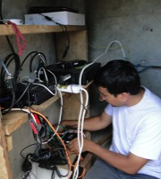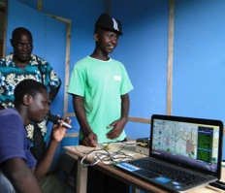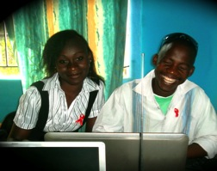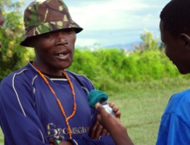

* Won $2,000 prize in UC Berkeley’s[*Big Ideas Competition*](mailto:http://bigideas.berkeley.edu/sites/default/files/2012%2520Big%2520Ideas%2520Winners%2520summary%2520sheet%2520FINAL.pdf)*, Creative Expression for Social Justice* category
* [***Access:Energy***](http://accessenergy.org) installed a 1kw wind + solar system atop Soklo Mountain to power EKR
* Worked with [***Inveneo***](http://www.inveneo.org) to deploy a 90-km, 1MB broadband Internet link at EK Center to transmit EKR’s waves off Soklo Mountain ranging 80-km across Lake Victoria
* Successfully installed the EKR on August 28, 2012!

Over a 5-day deployment Nepalese Radio Engineer Pawan Prakash Upreti set up EKR’s 500 watt FM Stereo Transmitter on top Soklo Mountain and connected transmission to EKR’s studio site located within the Ekialo Kiona Center at Kitawi Beach. Pawan generously donated his time and skills to complete this project.

* Partnered with [***Byce Broadcast & Technologies***](http://www.byce-broadcast.com), a Nairobi-based radio org, to provide in-country support including procurement and clearance of all EKR equipment at cost, equipment installation, and EK staff training.
* During EKR installation, trained 8 EKR Staff and youth on equipment and studio maintenance as well as basic broadcast and production techniques
* Hired EKR Radio Coordinator, Mr. Samwel Karan, and 3 EKR local youth Radio Presenters. All EKR staff are currently volunteering until future funds are secured.
* Began outreach to secondary school journalism clubs on Mfangano. After schools reopen in January, each club will be given time slots to broadcast a piece on EKR.
* EKR went LIVE on December 1, 2012! Complete with a launching ceremony, Mfangano youth along with members of Mfangano’s Council of Elders were given the opportunity to give Mfangano’s first LIVE radio broadcast.

EKR is East Africa’s first wind-powered radio!

The ***Ekialo Kiona Youth Radio*** (“EKR”) is a *for-youth, by-youth* community radio station with a focus on Suba language and culture. We reach tens of thousands of Suba residents along the shores of Lake Victoria. As a critical component of the ***OHR-MCI Initiative for HIV/AIDS,*** EKR will also connect over 500 microclinics currently organized and registered on Mfangano with a mission to improve HIV literacy, attitudes and behaviors in the community.

OHR-MCI officially launched **EK FM** on December 1ST! The day’s events were covered LIVE making it the first World AIDS Day to be broadcast across the lake!

Support for OHR-MCI's work to influence social networks of young people through the implementation of the youth radio station has come from the **Rise Up Foundation**. This support has been monumental, allowing OHR-MCI to provide a platform to empower orphans and at-risk youth to share their voices and cement a sense of solidarity across Lake Victoria.

EK FM . 99.3 . “Turi-alala”

SUBA FOR “WE ARE TOGETHER!”

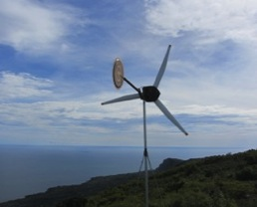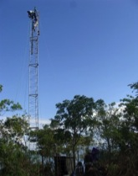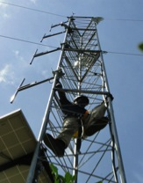

2012 ACCOMPLISHMENTS:

EK FM – EK YOUTH COMMUNITY RADIO

**World’s First Wind-powered Suba Radio!**

WWW.ORGANICHEALTHRESPONSE.ORG

* New MicroClinics on Mfangano (aka “kanyaklas in DhuLuo):

In 2012, OHR and MCI trained and graduated **46 “MicroClinics” comprising 529 Ekialo Kiona Club members**. Each microclinic is comprised on **5-15 HIV-positive and HIV-negative friends, relatives, and neighbors.** All microclinics completed an innovative **6-month, 12-session curriculum,** utilizing IT resources to explore HIV biology, anti-retroviral therapy, and nutrition for people living with HIV. These “kanyaklas” (meaning “together” or “team” in Luo) were facilitated by **28 specially trained Community Health Workeres** from Mfangano East.

* Community Disclosure:

Upon completion of the MicroClinic curriculum, **>90% of program participants** agreed to participate in formal Group HIV counseling and testing session, facilitating over **>100 HIV-positive participants to disclose their HIV status for the first time**.  To our knowledge, this is the first program in East Africa to facilitate successful community-wide disclosure on this scale.

* Mfangano Island Healthy Networks Impact Study (MIHNIS):

Finally, in collaboration with world-leading investigators from the Kenyan Medical Research Institute (KEMRI) and University of California San Francisco, OHR and MCI enrolled **402 AIDS-patients** on anti-retroviral therapy along with **413 members of their social support networks** into an **18-month longitudinal cohort study** to evaluate the long-term health impact of the MicroClinic program.   This study will enable cutting-edge publications and actionable programmatic data regarding social networking strategies for HIV/AIDS in Africa.

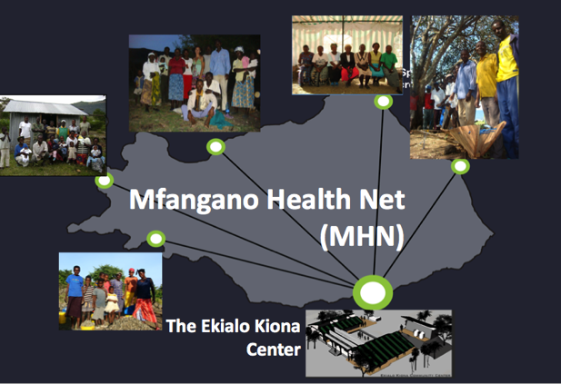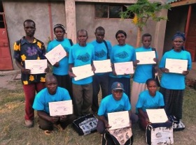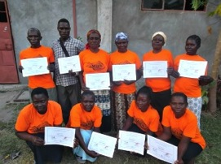

MFANGANO HEALTH NET (MHN)- MICROCLINIC PROGRAM

**OHR & Microclinics International Launch the “Mfangano Health Net:”**

**The World’s First Microclinic Program for HIV/AIDS**

This year, the OHR team grew rapidly from 19 in 2011 to a total of 47 Kenyan EK staff and 2 U.S. Operational staff in 2012. In addition, OHR was fortunate to have the help of numerous volunteers from across the world, both lending hands-on experience on the ground as well as distance support organizing fundraisers and awareness events.

WWW.ORGANICHEALTHRESPONSE.ORG

IN 2012, OHR ADDED 29 NEW STAFF MEMBERS TO OUR TEAM!

The Ekialo Kiona Center is run by a dedicated team of Kenyan staff and volunteers. The staff is responsible for all aspects of the center’s operation. From member registration to computer training to on-site farming to solar repair to nighttime security, the EK staff does it all!

All of the EK staff begin as OHR volunteers, eventually advancing into paid positions based on their hard work and dedication. As the primary earners of their respective families, their modest salaries bring valuable incomes to the Mfangano community, putting Ugali on the table and their children through school.

OHR STAFF & VOLUNTEERS

OHR PARTNERS

OHR SUPPORTERS

* Access:Energy
* Advocate Safehouse Project
* AMPATH
* Bicycles for Humanity – Colorado
* Byce Broadcast and Technologies
* Equal Access
* Family AIDS Care and Education Services (FACES)
* Global Tolerance
* Imani Workshops
* Inveneo
* Kenya Medical Research Institute (KEMRI)
* Kiva Zip
* Microclinics International (MCI)
* Setright
* Teach for Health
* University of California, San Franscico (UCSF)
* Youth Factor
* Well Told Story
* World Bicycle Relief
* Ashton Durrett Family
* Berkeley Big Ideas Competition
* Berkeley Clausen Fellowship
* Craig’s Jewish Community Federation
* David Akerson
* David Reinisch
* Elizabeth Hickey
* Forrest Lowell
* Fort Collin’s Breakfast Rotary Club
* Greg Lynch
* Judy Huston
* Microclinics International
* National Academy of Science
* Ray Lifchez
* Richard and Marianne Reinisch Foundation Rise Up Foundation
* Steve Christian Family

MANY THANKS

Without the endless support from our dedicated donors and committed partners and volunteers, OHR would not be able to maintain the fully functioning Ekialo Kiona Center at Kitawi Beach on Mfangano Island, Kenya.

OHR is based on a unique collaborative system. Our programs are designed and implemented by Mfangano residents working in small teams with student volunteers from around the world, and supported by IT industries, international “Green” movements, and global health partners. As an inspired cooperative of grass-roots activists, we are working together to plant seeds of solidarity and cultivate local visions of wellbeing.

$238,504 USD

WWW.ORGANICHEALTHRESPONSE.ORG

OHR FINANCIALS

$252,155 USD

OHR ADMINISTRATION: In 2013, we will turn our focus towards developing organizational and management systems for OHR to increase our effectiveness and transparency as a non-profit. This includes building human resources by hiring a U.S. Director of Operations as well as a Director of Development & PR. OHR is looking for outside funding to support OHR administration and operations.

WIFI INTERNET: OHR and their partners are working hard in 2013 to establish one of East Africa's first WISP (Wireless Internet Services Provider) to provide WIFI access for schools, clinics, orphanages, small businesses, etc on Lake Victoria.

EK RADIO: With the infrastructure in place, we plan to focus our energy in 2013 on staff training, as well as to secure funding for 2013 programming, studio upgrades and staff salaries.

REFORESTATION: We are looking forward to expanding our youth education services in 2013 with an integrated agriculture and forestry curriculum for high school students. In addition, we are anxiously awaiting the official Gazettement process to be complete by the Kenyan Government.

MHN: OHR-MCI will work towards expanding the current microclinics model across North and West Mfangano as well as develop short-term sessions for specialty kanyaklas such as church groups and youth.

RESEARCH: In 2013 we plan to finish data collection for MIHNIS, RECH and HNWT studies and facilitate unique global health opportunities for Kenyan, UCSF and UMN graduate students.

EK EMERGENCY: Through a partnership with the University of Minnesota, we plan to train and activate over 500 “Emergency Responders” in Summer 2013. We aim to further expand triage and treatment services available at the EK Center, and we’ll expand our local and international network of medical consultants.

WWW.ORGANICHEALTHRESPONSE.ORG

WHAT’S NEXT: 2013 AND BEYOND

As a 501-c-3 non-profit organization, all donations to OHR are tax deductible!

Stay updated on our projects ...

Get involved ...

Donate ...

“Seeding health possibilities through community-rooted partnerships.”

ORGANIC HEALTH RESPONSE

PO BOX 2780

GLENWOOD SPRINGS, CO 61802

WWW.ORGANICHEALTHRESPONSE.ORG